Internship task one

Redesign landing page an website LANDING PAGE AND REDESIGN IT TO IMPROVE USABILITY AND ASTHETICS

DESIGN BEFORE
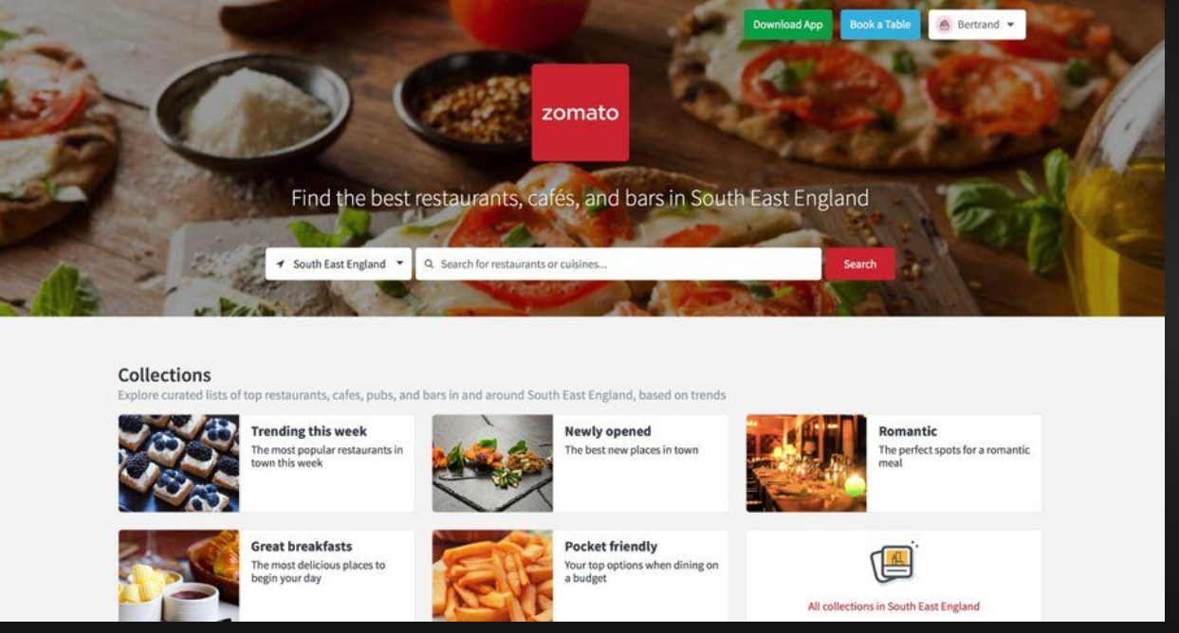

DESIGN AFTER

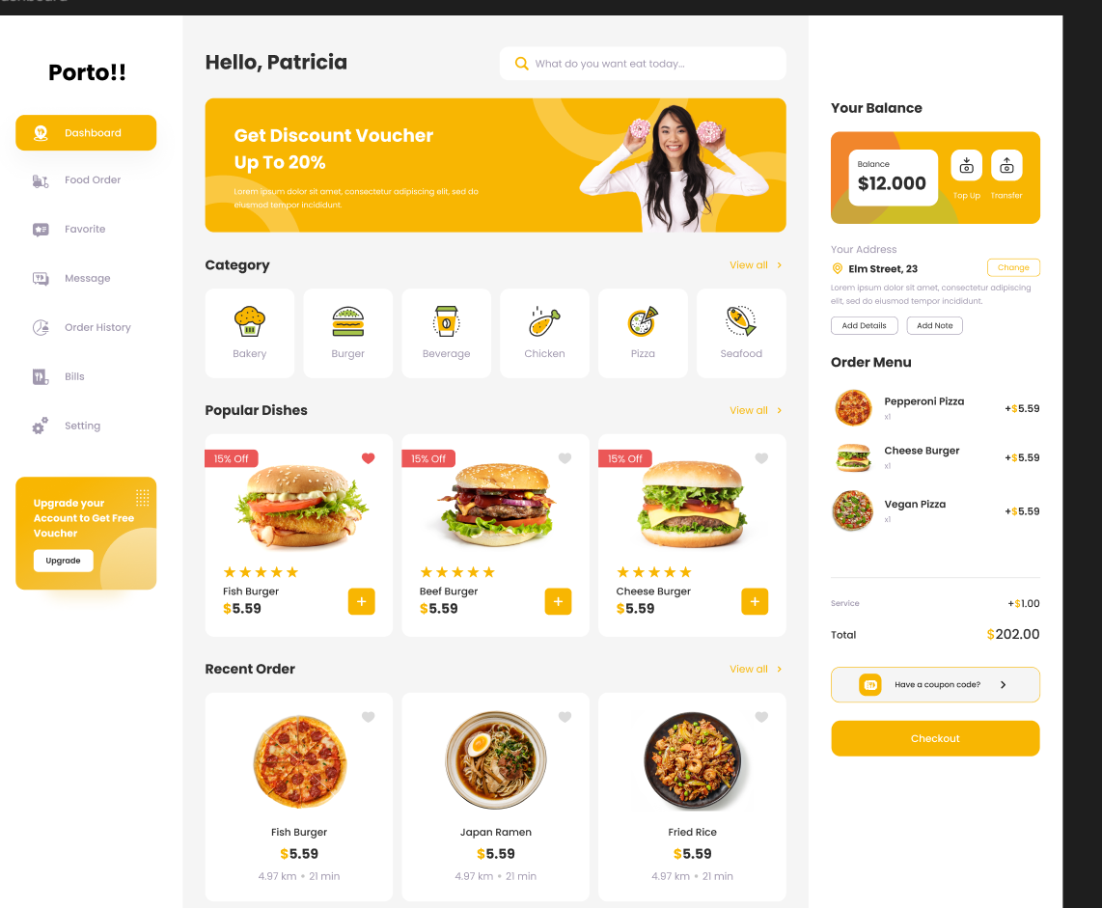
1. Introduction
The objective of this task was to analyze the existing Zomato landing page and redesign it with a more modern, vibrant, and user-friendly interface. The current webpage is functional, but certain areas can be improved to enhance user experience, visual appeal, and navigation clarity.
In this report, I have reviewed the original UI, identified its issues, and then proposed a redesigned version based on a Vibrant Food Theme UI (Red + Yellow) as selected.

2. Analysis of the Existing Zomato Landing Page
After observing the original Zomato landing page (screenshots provided), the following points were noted:
2.1 Visual Design Observations
- The page uses a strong red theme, but the color distribution is not fully balanced.
- Some sections feel dense with text and images placed closely.
- Spacing and alignment can be improved for a cleaner layout.
2.2 UI/UX Issues
- Too many elements appear at once, causing slight visual clutter.
- Lack of visual hierarchy makes important sections (like search) blend into the background.
- Category cards feel repetitive and lack contrast.
- Navigation could be more prominent.
2.3 User Experience Gaps
- First-time users may feel overwhelmed by too many category blocks.
- Icons and typography sizes are not fully optimized.
- Search bar can be more interactive and visually engaging.

3. Key Problems Identified
Area | Issue
Layout | Overcrowded sections and inconsistent spacing
Color | Heavy red blocks reduce readability
Cards | Repetitive layout, minimal visual differentiation
Text | Font hierarchy could be improved
Navigation | Not highlighted enough in the top fold

4. Design Direction Chosen: Vibrant Food Theme UI
I chose Option B – Vibrant Food Theme UI, focusing on:
- Strong food-based colors (yellow, red, orange)
- Cleaner layout with breathing space
- Modern card design with shadows and rounded corners
- Better hierarchy and spacing
- A visually appealing hero section with bold typography
This redesign keeps the “Zomato identity” but gives it a fresher, more exciting, and modern look.

5. Redesigned Landing Page (My Version)
5.1 Hero Section
- A bright yellow + red blended background.
- Large, bold headline: “Discover the Best Food Around You”
- A centered, rounded search bar with icons (location + food search).
- Simple navigation bar with softer gradients for better readability.
5.2 Category Section
Redesigned into three modern card types:
- Food Delivery (with a bright red banner)
- Dining Out (with soft yellow highlights)
- Nightlife (with darker themed overlays)
All cards use:
- Rounded corners
- Soft shadows
- High-quality food imagery
- Larger spacing between cards
- Title + short subtitle in clean typography
5.3 Popular Collections
- Four cards with full-width imagery and gradient overlays.
- Cleaner spacing and minimal text overlay.
- Buttons redesigned to pill-shaped style.
5.4 Footer Redesign
- More breathable layout.
- Better spacing between links.
- Improved readability with lighter background.

6. Before vs After (Comparison Table)
Feature | Before | After (My Redesign)
Color Theme | Heavy red | Balanced red + yellow food theme
Search Bar | Basic, long | Rounded, centered, more interactive
Category Cards | Similar look | Differentiated with colors + modern shadows
Layout | Slightly cluttered | Clean spacing, better alignment
Typography | Thin hierarchy | Bold headings + readable subtitles
Navigation | Low contrast | Clear, modern, highlighted options
Images | Overlapping visuals | Clearly structured, fresher visuals

7. Why This Redesign is Better
- Improved readability due to balanced colors.
- Stronger visual hierarchy helps users focus on important actions.
- Modern UI trends such as rounded cards, shadows, and clean spacing.
- Better user engagement through vibrant colors and attractive imagery.
- More intuitive navigation for both new and returning users.

8. Conclusion
The redesigned Zomato landing page enhances both visual appeal and user experience while maintaining the identity of the brand.
By using a vibrant food theme, adding structured spacing, improving card design, and upgrading typography, the overall page looks more modern, interactive, and user-friendly.
This report documents the complete analysis, design issues, and the improved version created as part of Internship Task-1.

